class Account {

private String name;

private String account;

private double bal;

public Account(String name, String accnum, double bal) {

this.name = name;

this.account = accnum;

this.bal = bal;

}

public void deposit(double amt) {

if (amt > 0) {

bal += amt;

System.out.println("Deposited: " + amt);

} else {

System.out.println("Invalid Deposit");

}

}

public void displayBal() {

System.out.println("Balance: " + bal);

}

public void withdraw(double amt) {

if (amt > 0 && amt <= bal) {

bal -= amt;

System.out.println("Withdrawn: " + amt);

} else {

System.out.println("Insufficient Funds");

}

}

public double getBal() {

return bal;

}

public void setBal(double bal) {

this.bal = bal;

}

}

class SavAct extends Account {

private static final double int_rate = 6.05; // Interest rate for savings account

public SavAct(String name, String accnum, double bal) {

super(name, accnum, bal);

}

public void addInterest() {

double interest = getBal() * int_rate / 100; // Interest is calculated on the balance

setBal(getBal() + interest);

System.out.println("Interest added: " + interest);

}

}

class CurAct extends Account {

public static final double win_bal = 500; // Minimum balance for checking account

public static final double penalty = 50; // Penalty for below minimum balance

public CurAct(String name, String accnum, double bal) {

super(name, accnum, bal);

}

public void withdraw(double amt) {

if (amt > 0 && getBal() - amt >= win_bal) {

setBal(getBal() - amt);

System.out.println("Withdrawn: " + amt);

checkMinBal();

} else {

System.out.println("Insufficient Funds");

}

}

private void checkMinBal() {

if (getBal() < win_bal) {

setBal(getBal() - penalty);

System.out.println("Below min balance, penalty applied: " + penalty);

}

}

}

public class Bank {

public static void main(String[] args) {

SavAct savacc = new SavAct("Rahul", "Rahul13", 1000);

CurAct curacc = new CurAct("Rohan", "Rohani4", 500);

System.out.println("Savings Account: ");

savacc.deposit(500);

savacc.displayBal();

savacc.addInterest();

savacc.withdraw(200);

savacc.displayBal();

System.out.println("\nCurrent Account: ");

curacc.deposit(300);

curacc.displayBal();

curacc.withdraw(1000); // Should show insufficient funds

curacc.displayBal();

curacc.withdraw(200); // Should show below minimum balance penalty

curacc.displayBal();

}

}

Output:

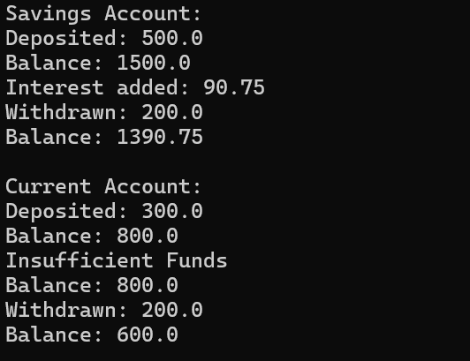

2)PACKAGE :